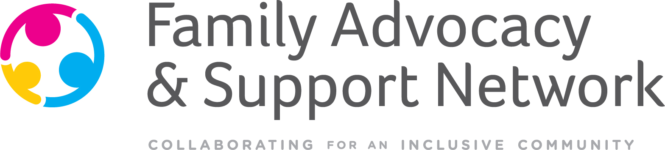

VOLUNTEER APPLICATION

Name: Date:

Primary Phone: Alternate Phone:

Email Address:

How did you hear about us?

Do you have any past experience interacting with an individual who experiences an intellectual or developmental disability?

Please describe hobbies, skills, and/or previous volunteer or work related experiences that would be applicable to our needs:

Why are you interested in becoming a volunteer with FASN? What do you hope to gain out of the experience?

Which days/times are you available to volunteer?
 | Morning | Afternoon | Evening
Monday
Tuesday
Wednesday
Thursday
Friday
Saturday
Sunday

Are you at least 16 years of age? (circle one): Yes or No

Are you willing to submit to a background check and/or drug screen? (circle one): Yes or No

Questions? Contact Charlene Dobry 541-880-4863 Charlene@fasnfamilynetwork.org or
Yecenia Rodriguez 541-591-5507 Yecenia@fasnfamilynetwork.org

